First download winutils.exe from below link and place it to <folder>/bin folder

<http://public-repo-1.hortonworks.com/hdp-win-alpha/winutils.exe>

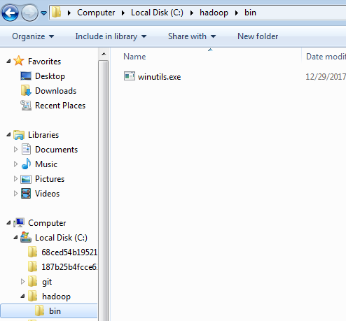

In build.sbt file add dependency for spark

|  |
| --- |
| *libraryDependencies* += **"org.apache.spark"** %% **"spark-core"** % **"2.1.0"** *libraryDependencies* += **"org.apache.spark"** %% **"spark-sql"** % **"2.1.0"** |

Set property for Hadoop home directory as shown below

|  |
| --- |
| **object** SparkJob {  **def** main(args: Array[String]): Unit = {  System.*setProperty*(**"hadoop.home.dir"**, **"c:\\hadoop\\"**);  *createParquet* }  **def** createParquet (): Unit = {  **val** file = **"C:/RSI_POC/META_TABLES/META_SUBVENDOR_MAPPING.txt"  val** outputFolder = **"C:/RSI_POC/META_TABLES/Parquet/META_SUBVENDOR_MAPPING"** */*val file = "C:/RSI_POC/META_TABLES/META_UPC_PREFIX.txt"  val outputFolder = "C:/RSI_POC/META_TABLES/Parquet/META_UPC_PREFIX"*/* **val** spark = SparkSession.*builder*().appName(**"test"**).master(**"local"**).getOrCreate()   **val** df = spark.read.format(**"com.databricks.spark.csv"**)  .option(**"header"**, **"true"**)  .option(**"delimiter"**,**"\\t"**)  .option(**"inferSchema"**, **"true"**)  .load(file)   df.write.mode(**"overwrite"**).parquet(outputFolder)   df.show(10)  }  } |

Now you can able to write file, without winutils.exe setting you can’t able to write file on system